Session-5 Lab

Assignment 1

package com.anudip.assigment_5;

import java.util.Scanner;

public class SimpleInterestCalculator {

public static void main(String[] args) {

Scanner sc = new Scanner(System.***in***);

// Taking principal amount input

System.***out***.print("Enter Principal Amount: ");

double principal = sc.nextDouble();

// Taking time input

System.***out***.print("Enter Time (in years): ");

double time = sc.nextDouble();

double rate;

// Determine interest rate based on principal

if (principal > 10000) {

rate = 10.0;

} else if (principal >= 5000) {

rate = 8.0;

} else {

rate = 5.0;

}

// Calculate Simple Interest

double simpleInterest = (principal * rate * time) / 100;

// Display results

System.***out***.println("\nPrincipal Amount: " + principal);

System.***out***.println("Time (years): " + time);

System.***out***.println("Rate of Interest: " + rate + "%");

System.***out***.println("Simple Interest: " + simpleInterest);

sc.close();

}

}

Output

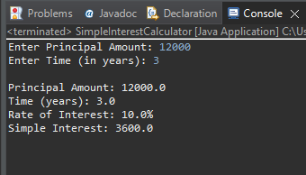

Assignment 2

package com.anudip.assigment_5;

import java.util.Scanner;

public class MarksCalculator {

public static void main(String[] args) {

Scanner sc = new Scanner(System.***in***);

double totalMarks = 0;

int numberOfSubjects = 5;

// Taking marks for 5 subjects

for (int i = 1; i <= numberOfSubjects; i++) {

System.***out***.print("Enter marks for subject " + i + " (out of 100): ");

double marks = sc.nextDouble();

// Validate marks

if (marks < 0 || marks > 100) {

System.***out***.println("Invalid marks! Please enter between 0 and 100.");

i--; // retry the same subject input

continue;

}

totalMarks += marks;

}

// Calculate average percentage

double average = totalMarks / numberOfSubjects;

// Determine grade

String grade;

if (average > 90) {

grade = "Excellent";

} else if (average > 80) {

grade = "A+";

} else if (average > 60) {

grade = "B+";

} else if (average >= 40) {

grade = "C+";

} else {

grade = "Failed";

}

// Display results

System.***out***.println("\nTotal Marks: " + totalMarks + " out of 500");

System.***out***.println("Average Percentage: " + average + "%");

System.***out***.println("Grade: " + grade);

sc.close();

}

}

Output

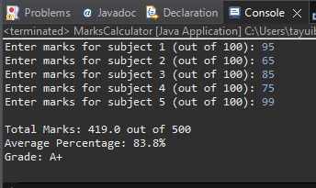

Assignment 3

package com.anudip.assigment_5;

import java.util.Scanner;

public class InternetBillCalculator {

public static void main(String[] args) {

Scanner sc = new Scanner(System.***in***);

// Input: total data consumed in GB

System.***out***.print("Enter total data consumed (in GB): ");

double dataGB = sc.nextDouble();

double billAmount;

// Billing logic using if-else

if (dataGB < 10) {

billAmount = 300.0; // Basic charge

} else if (dataGB <= 30) {

billAmount = 300.0 + 5.0 * (dataGB - 10.0);

} else {

billAmount = 400.0 + 3.0 * (dataGB - 30.0);

}

// Output: final bill amount

System.***out***.printf("Monthly Bill Amount: Rs. %.2f%n", billAmount);

sc.close();

}

}

Output

